**1.** Create one repository in git, Clone it in your system, push directory and file structure in git.

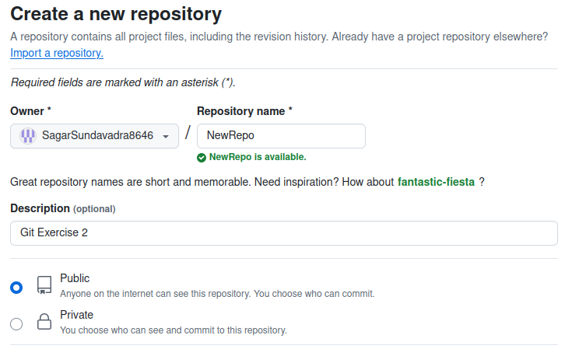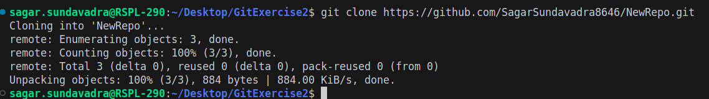

**2.** Create ‘**dev**’ branch from master and push some contents (directory with two files) inside this ‘**dev**’ branch.

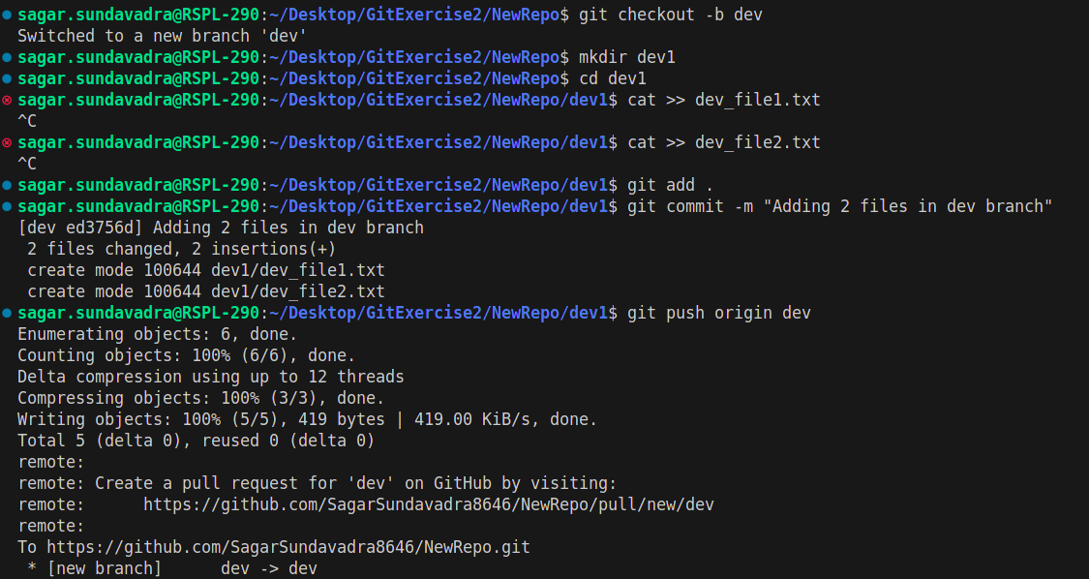

**3.** Create ‘**branch1**' branch from ‘**dev**’ branch, create one file in ‘**branch1**’, as well as create ‘**branch2**’ branch and add one file for this branch too.

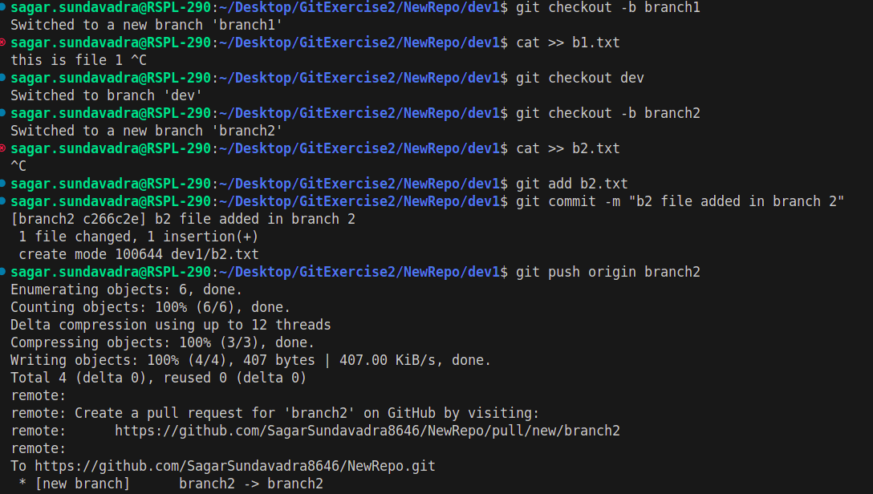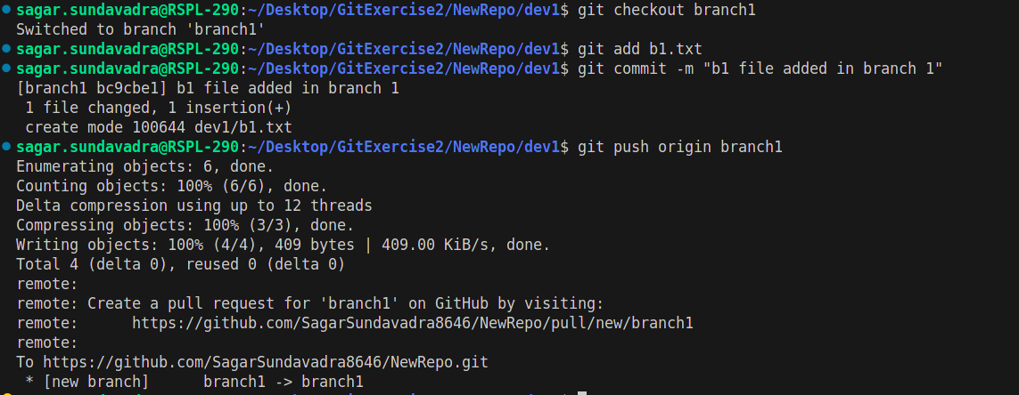

**4.** Change some contents in existing file inside ‘**branch1**’ branch, and do same thing for ‘**branch2**’

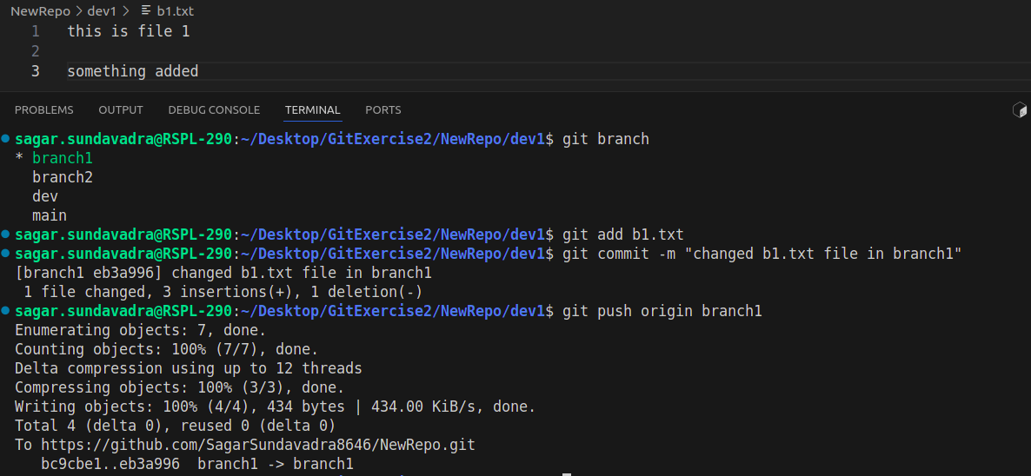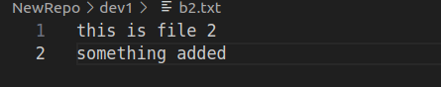

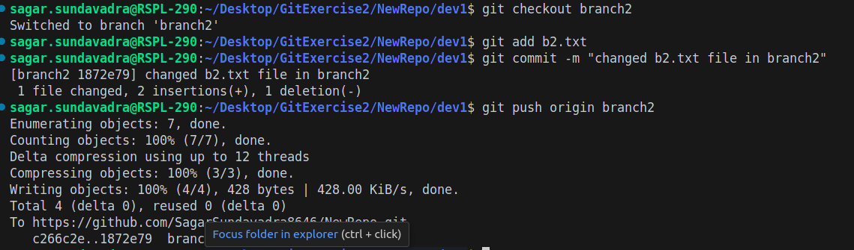

**5.** Commit those changes and after committing, change the commit message.

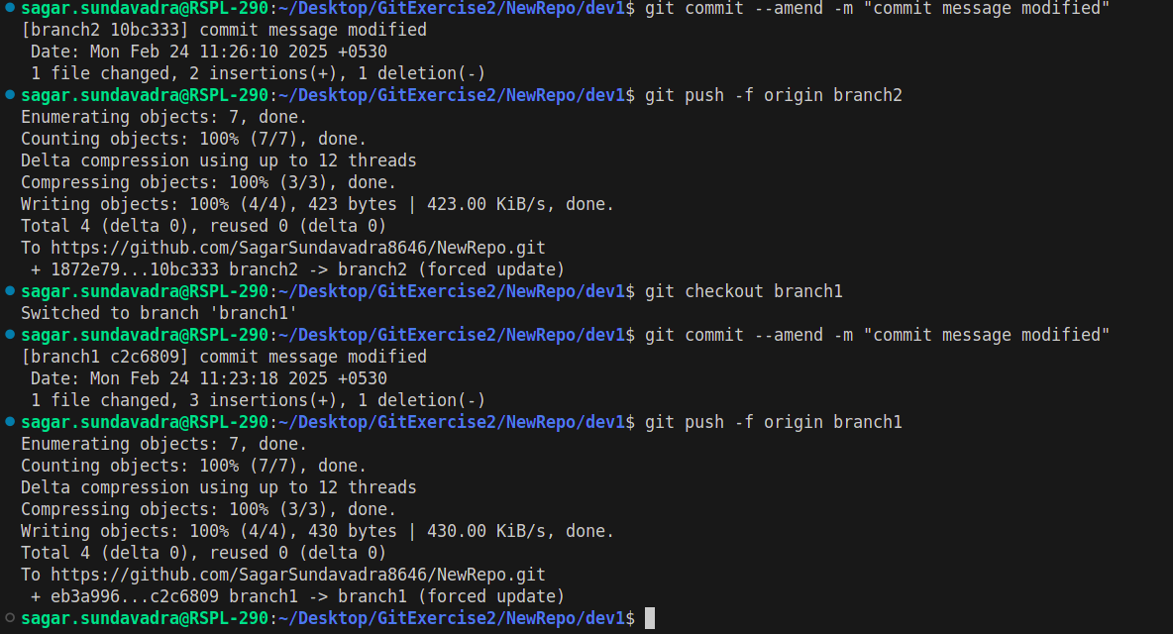

**6.** After changing commit message you have to push your new changes on git. **(NOTE: if you get any conflicts then resolve it and then push that in git.)**



**7.** Merge ‘**branch1**’ and ‘**branch2**’ in dev branch.

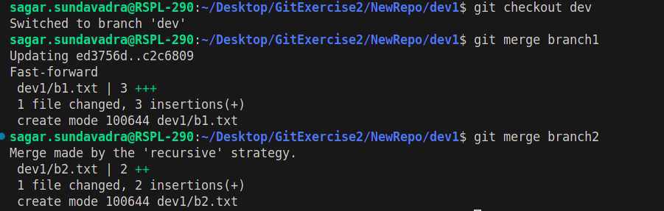

**8.** Follow the steps:

(a). Make a few changes in ‘**branch1**’ contents

(b). Without ‘adding and committing those changes' (**branch1**), make some changes in **branch2** contents (stash your **branch1** changes and then apply some changes in **branch2**)

(c). Add and commit your **branch2** changes and then come back to **branch1** and get back your stash changes.

(d). Merge **branch1** and **branch2** in **dev** branch.

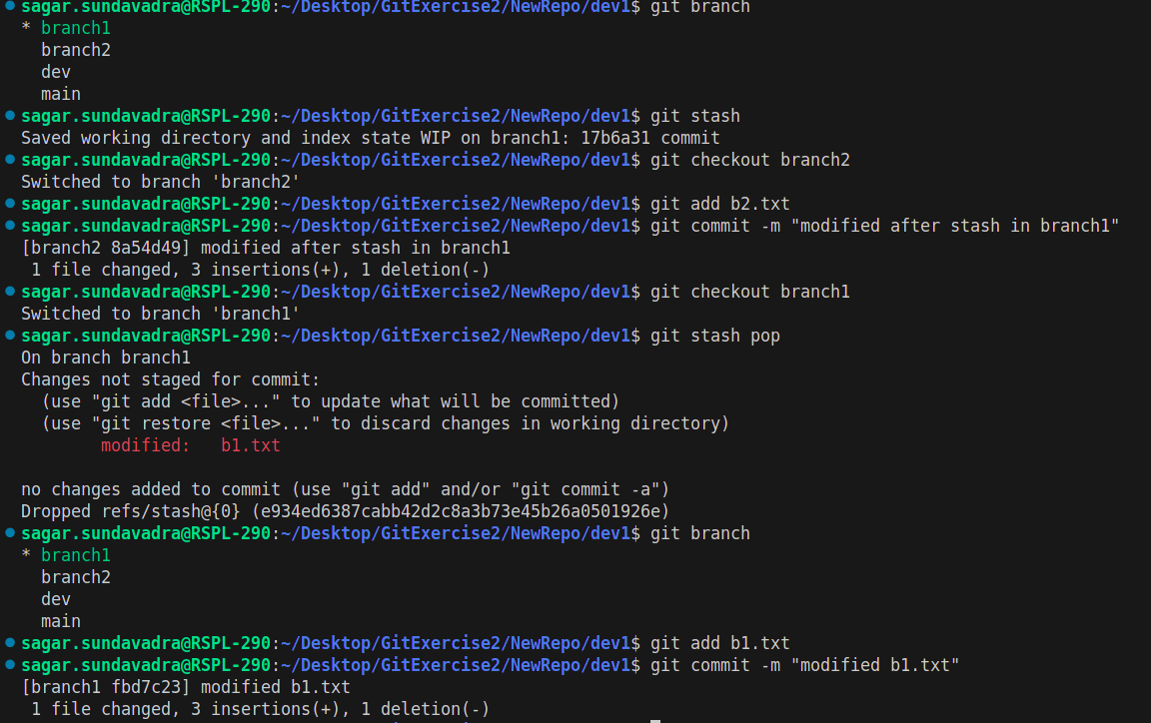

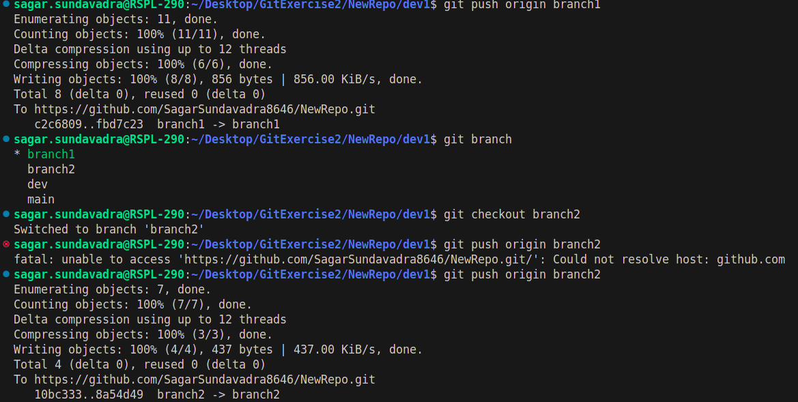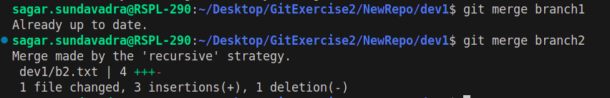**9.** Follow the steps:

(a). Create two branches from dev, i.e. ‘**feature1**’ & ‘**feature2**’.

(b). Add some content in ‘**feature1**’ as well as add some content in ‘**feature2**’

(c). Push ‘**feature1**’ on git

(d). Take pull of ‘**feature1**’ in ‘**feature2**’

(e). Merge ‘**feature1**’ into ‘**dev**’ branch

(f). Take pull of ‘**dev**’ branch

(g). Push your ‘**feature2**’ on git

(h). Rebase ‘**feature2**’ with ‘**dev**’ branch and then merge ‘**feature2**’ in ‘**dev**’.

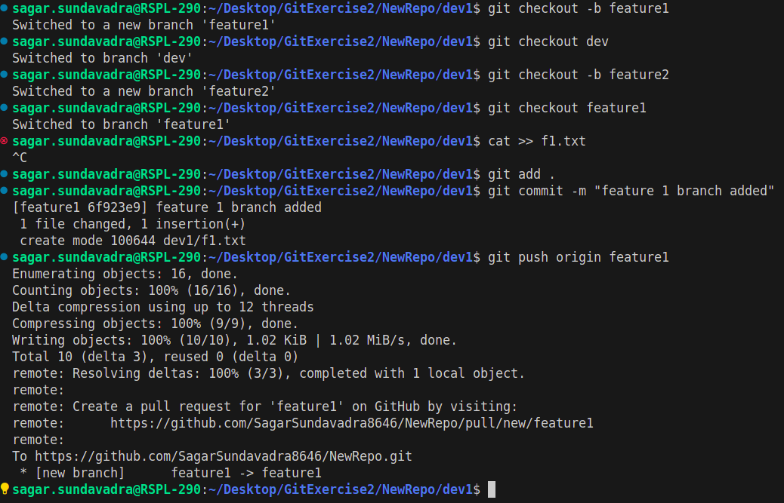

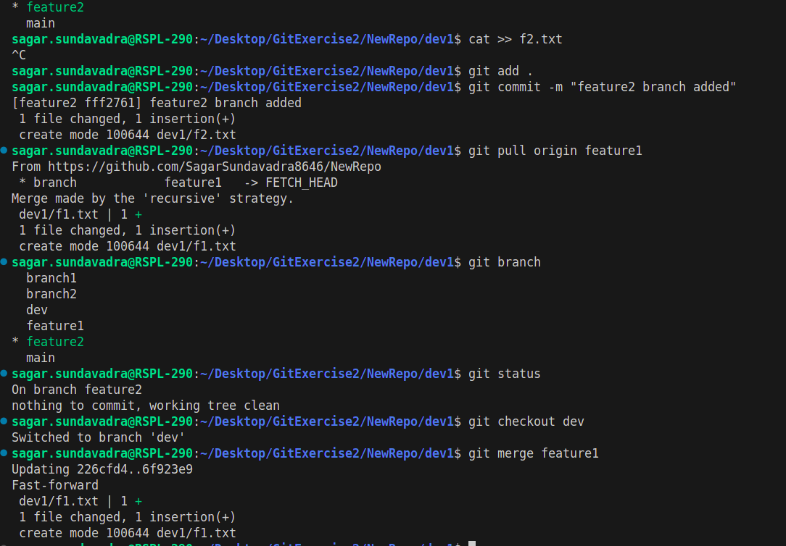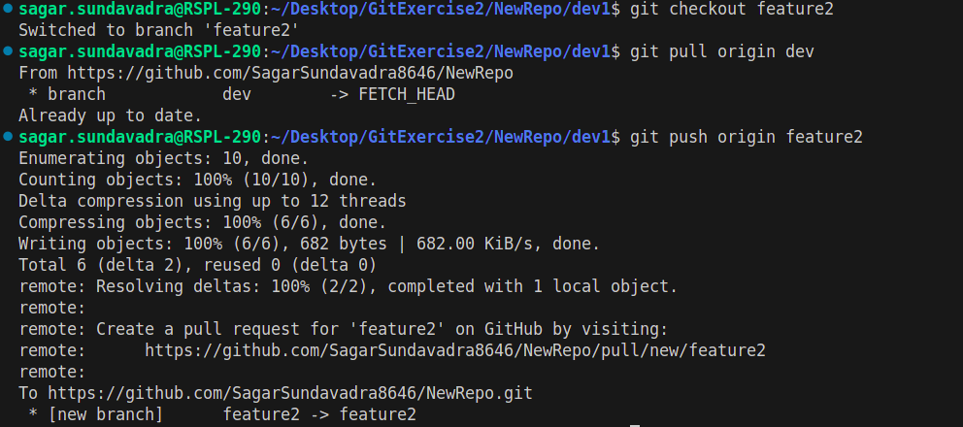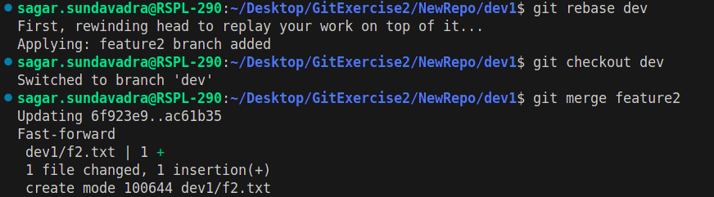

**10.** Merge **dev** branch in master branch

